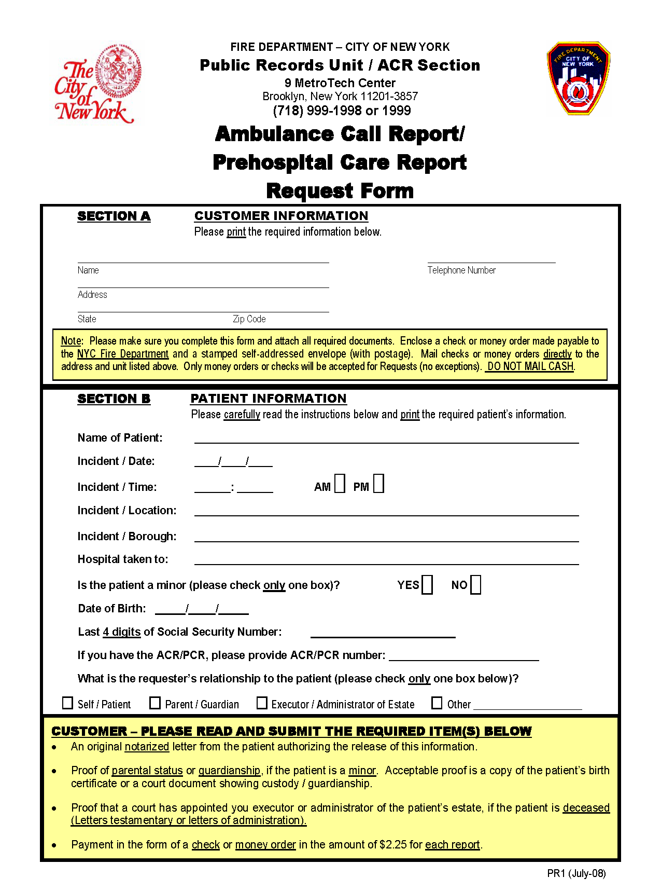
Kendall Kenard Blond
Axiom Requisition Copy Service
2869 Jolly Road, Okemos
MI 48864
(877) 886-5090
05/27/1987
439-65-1932
Order Number: 01-36296-003
X DEFENSE ATTORNEY

